University of Wah
Department of Computer Science

Submit to:

Mr. Hassan Shafaqat

Submit by:

Muhammad Talha

Course:

Artifical Intelligence_Lab CS-202L

Reg No:

UW-24-CS-BS-101

Section:

BS-CS-3rd-B

Task # 01

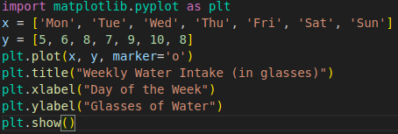

OutPut

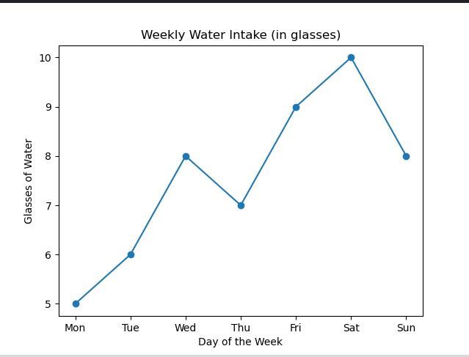

Task # 02

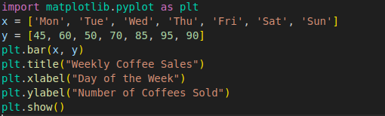

Output

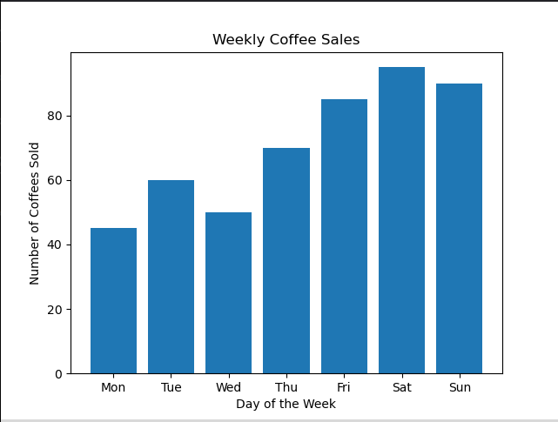

Task # 03

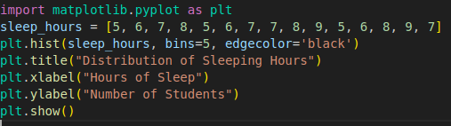

Output

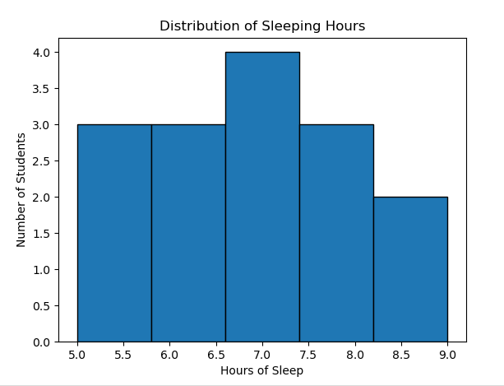

Task # 04

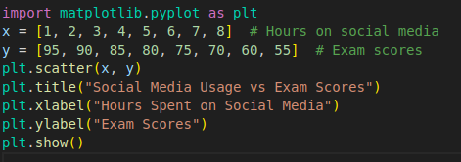

Output

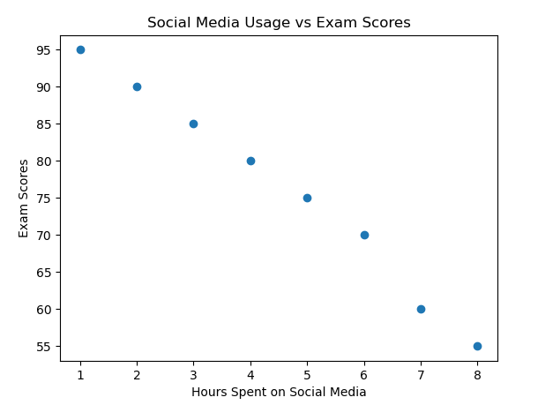
Task # 05

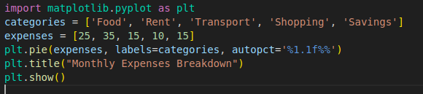

Output

